**[Verthicha]**

**Overview – pitch**

If you’re looking for a game that lets you experience thrilling and amazing adventures, slaying monsters and wild life, concur legendary dungeons, look for rare treasures and much more. Than the Verthicha is just the game for you.

Verthicha is an third-person perspective action role-playing game for PC and Xbox one which offers the players with a massive open world environment filled with wild animals, monsters, dungeons, caves, cities, towns, fortresses and villages for the player to explore and enjoy.

In the Verthicha the players is constantly required to make decisions. These decisions will affect and impact their experience of the game from things like deciding whether to attack a group of bandits, help free the prisoners, whether to complete the main quest of the game or to explore the land of Ariandel, what character class should the character be, what Armor and weapons to use and against which opponents. Thanks to all of the different choices the player will need to undertake during the gameplay, every single player will experience Verthicha in their own unique way making their own story as they progress through the game.

So what are you waiting for join the clan and experience the wonderful world of Ariandel and create your own story.

**Look & Feel**

**Look**

The player will be placed in the huge world of Ariandel that is filled with mountains, forests, lakes, caves and rivers running through the world as well as cities, towns and villages scattered around the world. The player will be able to see this world in third-person perspective just like in Witcher 3 or in Skyrim.

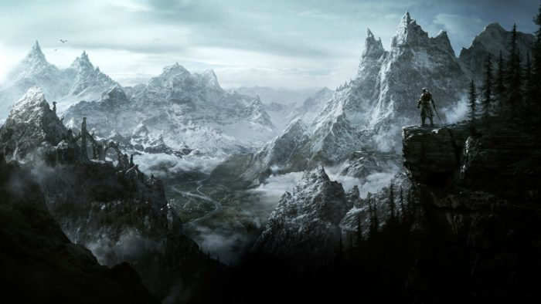The game world of Verthicha will be similar to Skyrim’s and Witcher’s 3 worlds as the world will be filled with big open fields that the player can explore and fight monsters in and, rocky mountains with narrow passages making it more difficult for the player to fight or cold areas where the enemies are slower due to the fact that the environment around them is so cold. As well as deep forests that will make it hard for the player to see how many enemies he’s currently facing.

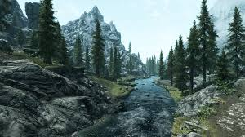

Figure 1 and 2: are pictures from Skyrim made by Bethesda Game Studio

**Feel**

I want to make player feel like they are in the olden times. In times where there are no guns, cars, planes or tanks. Where swords, bows and magic are the ways of fighting off enemies. Where the world is ruled by entities that are far more powerful than the humans. I want the players to feel accomplishment when they defeat an entity or a being that is much more powerful than the player. Just like in dark souls 3 when a player gets the satisfaction of beating an incredibly difficult boss.

Just like Skyrim, Dark Souls3 and Witcher3 I want the players to feel engaged in the world that is around them. For the players to experience a fantasy version where they can be anyone they want a powerful mage, a glorious warrior, a stealth thieve or a dark lord who kills anyone they see.

Thanks to the number of different three main character classes which are available to the player and the vast amount of choices that the player will need to undertake. Every playthrough of the game will feel special and unique to the player.

**Story**

**Backstory**

**Main playable character**

The player character is a prisoner of Drep Heap and was meant to be executed for crimes which he has not commited. However he was saved by a surprise attack from Lazmrut on the Drep Heap fortress and thanks to the chaos the player manages to escape in the chaos that Lazmrut are causing. During the escape the main playable character meets Validv Zrfpe who helps the player escape from the prison and he knew the land like the outside of his hand, and so together with Validv Zfrpe the main playable character escape Drep Heap unscratched.

**Non Playable Character** Validv Zrfpe

Validv is a sellsword that was born in the land of Ariandel and he has seen the beauties of the world and the horrors that were caused by the Treskri Sonear.

Validv has decided to become a sellsword because of his natural talent with swords and his fighting instinct. Which came useful for him multiple times during his adventures and quests that he has undertaken. Validv is an old men with long hair and a muscular body that not only provides strength but also the speed to strike quickly and accurately against his opponents. Validv has been imprisoned as he beat up a noble rich man that thought he was better than the whole world and all Validv did was put him back in his rightful place. Validv meets the main playable character in Dreg Heap during the chaos that the Lazmrut are causing and helps the main playable character escape from the prison. However because of a collapsing celling Validv and the main playable character are split apart from one another and Validv needs to find another way out from the prison. After a number of tedious fights he finally makes it out of the prison and returns back home to Lothric where he lays low for couple of weeks until he’s ready to go back out into the world as a sellsword once again.

**Non Playable Character** Akipi Huzdyr

Akipi Huzdyr is a mage from outside of Ariandel he came to Ariandel in pursuit of arcane arts, magical artefacts and more magic wisdom that would allow him to become more powerful and increase his magicka.

In his pursuit of power he stumbled across an artefact of Sjach which give him incredible magical powers. Akipi used this incredible magic power to challenge Treskri Sonear and he would have almost won if not for the fact. That Treskri has already spited his soul and gave it to his five monster generals. Without any soul in his body Treskri was invincible and Akipi didn’t stand a chance. So in his final struggle he banished Treskri from Ariandel and died shortly after leaving the artefact of Sjach behind. No one knows what happened to the artefact after Akipi has died.

**Narrative**

The game Verthicha takes place in Ariandel a land filled with mountains, fields, dragons, monsters and wild life. 200 years before the game Verthicha takes place there was an active demon lord, devourer of worlds (as humans called him) Treskri Sonear who ruled over Ariandel for 100 years until he was challenged by a mage called Akipi Huzdyr who didn’t manage to beat the demon lord however he did manage to ban Treskri Sonear from Ariandel since Treskri split his own soul among his five monster generals. Without his own soul Treskri is unable to return back to Ariandel so he remains dormant in Sovngarde where he waits patiently for a chance to return back to Ariandel and rule it once more with chaos and fire. After Treskri has been banished from the lands the humans started to develop villages, cities and towns. When the game Verthicha takes place there is a war happening between two great cities Lazmrut who is respected for being the first formed city of Ariandel and The Ringed City who is recognised for its ringed city wall of defences. The two cities are at war over territory as Lazmurt wants to move their boarders into the ringed city region and obviously the ringed city doesn’t want them to do that so they started a war with one another. During the game it will be up to the player do decide which one of does cities will win the war or if they will come into an agreement.

.

**Interface**

The user interface of Verthicha is going to look similar to the user interface in Dark Souls 3, as both games are played in third person. Positioning the health, stamina and magicka bars in the left top corner of the screen allows the user to monitor their health, stamina and magicka during battle without the need of opening special menus during combat.

Another reason why the health, stamina and magicka are placed in the top left corner of the screen is because it helps the player with stamina management since they are able to see how much stamina they waste on each attack and how much magicka they waste on each spell cast.

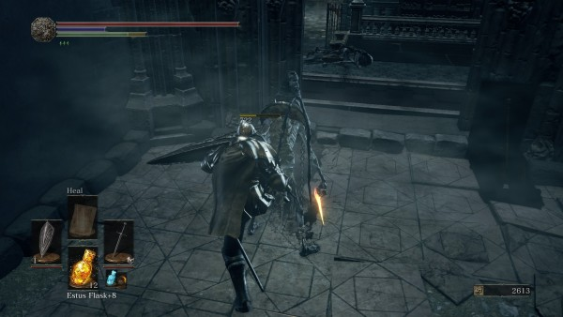

Figure1: image of health, stamina and FP in Dark Souls 3 which is made by FromSoftware.

The weapons and spells that the player’s avatar is currently using will be displayed in the bottom left corner of the screen, so that the player is able to identify what item they are currently using without needing to go into the inventory to check. Also by positioning the currently equipped weapons and spells in the bottom left corner of the screen allows the player to cycle through their weapons during combat without opening their inventory, as well as give them the ability to quickly swap their fighting style without needing to access any additional menus.



Figure 2: Image of quick inventory from Dark Souls 3 which is made by FromSoftware.

Another part of the user interface will be the minimap. Which will be placed in the top right hand corner of the screen, so that the player will be able to tell where they are currently in the world. The minimap will display the current time and weather of the world as well as display hostile enemies that the player is currently in combat with.

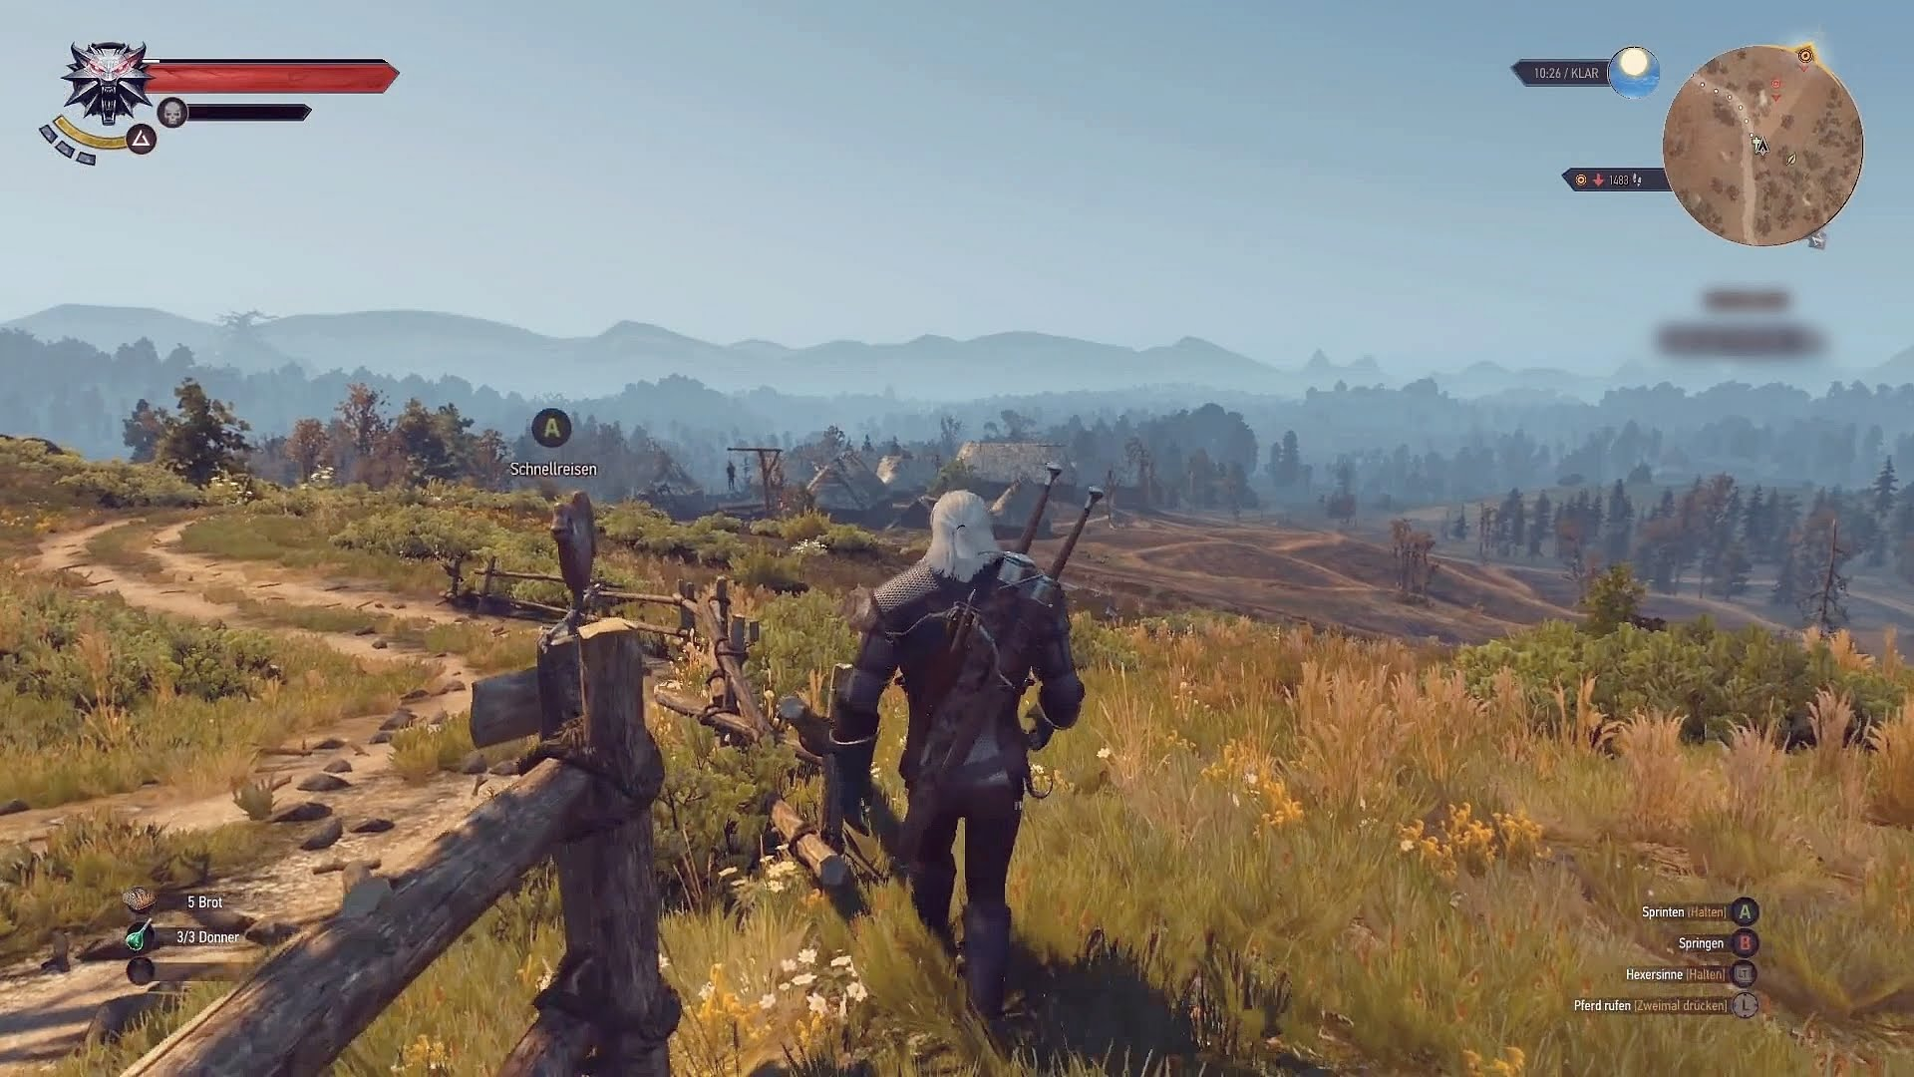

Figure 3: Image of the minimap from witcher 3 made by CD Projekt RED.

The character level up system will work similarly as in Skyrim. Which means that in order to level up destruction magic that consists of fire, ice, lighting, darkness and wind magic the player will need to use the destruction spells often against his enemies to level up does types of spells.

The way that the level up menu will be presented is each skill will be represented as a star constellations just like in Skyrim. So the player will need to start at the bottom of the constellations and make their way up to unlock more powerful skills.

Figure 4: Image of the destruction magic from Skyrim made by Bethesda Game Studio

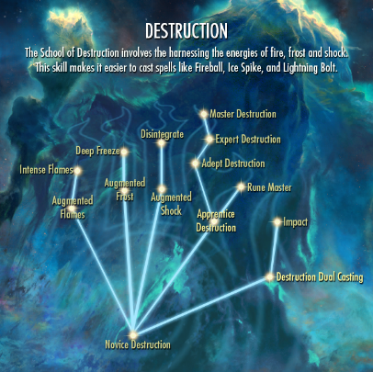

The equipment inventory will be similar to the inventory system from dark souls 3 since the player will be able to equip 3 different items in each of their hand and they will also have different armour sets that they can use. Setting up the menu this way will allow the player to place their weapons in the order that they want. Also the menu is simple and easy to understand.

Figure 5: Image of inventory layout from Dark Souls 3 which is made by FromSoftware.

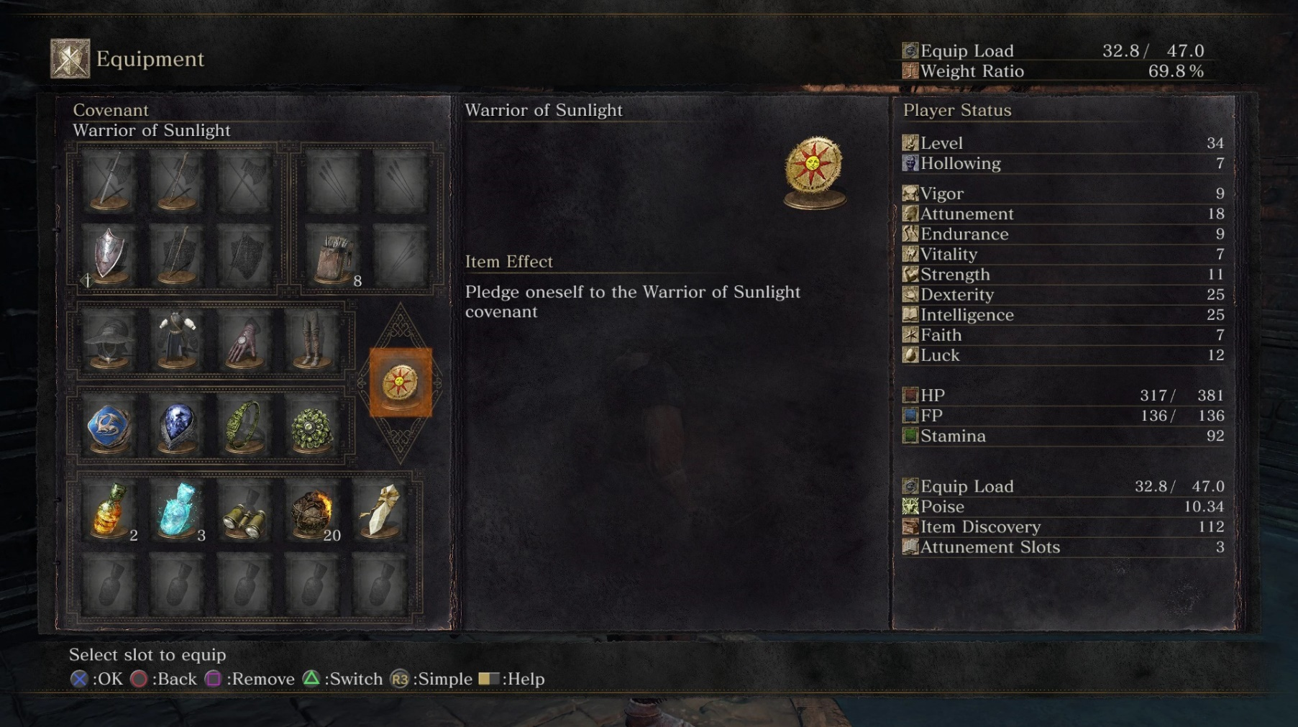

**PC Controls**

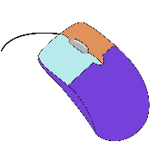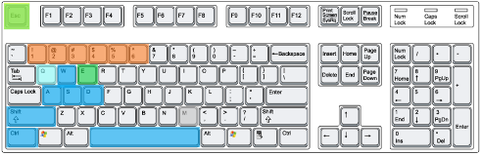Below is the table that specifies all the user interface controls for the PC version of the game. The PC Control layout has been designed so that all the actions are close to the user’s hands without the need for them to reach for a key that is on the other side of the keyboard.

|  |  |  |
| --- | --- | --- |
| **Controls** | **Actions** | **Notes** |
| W,A,S,D | Move | Press a key to move in that direction. |
| Space | Sprint | Press and hold one of the move directions and then Hold **Space.** |
| Space | Roll | Press and Hold (**W**, **A**, **S**, **D**, **W+A**, **W+D**, **S+A**, **S+D**)+**Space** to perform a roll in different directions. |
| Left Alt | Walk | **Left Alt** + **W**, **A**, **S**, **D** to walk. |
| Space | Jump | Press and Hold one of the directions + hold **Space** + press **Space** again to jump. |
| Space | Backstep | Press the **Space** to backstep. |
| R | Use Item | Press **R** to use the item like healing potion. |
| E | Interact | Press **E** to interact with loot, doors, etc.… |
| Right Click | Right Hand Attack | Weak Attack with the weapon that is held in the right hand.  If the right hand is empty or it contains a spell it will result in a punch. |
| Left Click | Left Hand Attack | Weak Attack with the weapon that is held in the Left hand.  If the left hand is empty or it contains a spell it will result in a punch. |
| Shift + Right Click | Strong Right Attack | If the right hand has a weapon equipped it will result in strong attack. If the right hand has a spell equipped it will result in casting the spell. If the right hand has nothing equipped it will result in a strong punch. |
| Shift + Left Click | Strong Left Attack | If the left hand has a weapon equipped it will result in strong attack. If the left hand has a spell equipped it will result in casting the spell. If the left hand has nothing equipped it will result in a strong punch. |
| Two hand spells | C | Switches to duel cast of spells if the spells in both hands are the same. |
| Two hand Weapon | V | Duel-Wields the weapon in the right hand. |
| Gestures | G | Opens Gestures menu with all the gestures that the character can do. |
| Character Menu/Inventory | Tab | Opens the Character menu where the player can level up their character and access their inventory. |
| Pause Menu | Esc | Opens the pause menu |
| Block | B | Blocks if the left hand has a shield equipped or if the player is duel-wielding a weapon. |
| Change Right-Hand | 1,2,3 | Scrolls through the items that the player has equipped in the right hand. |
| Change Left-Hand | 4,5,6 | Scrolls through the items that the player has the equipped in the left hand. |
| Camera | Mouse | Camera is being controlled by the mouse. |
| Camera Lock On/ Lock Off | Q | Locks onto the enemy that is closest to the player. |

**Xbox One Controls**

Below is the diagram that specifies the button layout for the Xbox One version of the game. The button mapping for the Xbox one has been done so that it’s easy to use and at the same time comfortable for the player.

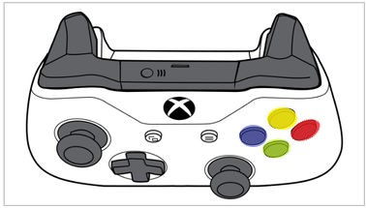

**LT**

**- Strong Attack** (With Weapon Equipped or fist)

**- Cast Spell** (If Spell Equipped)

**- Dual Cast = LT + RT** (If both hands have the same spell Equipped)

**LB**

**- Weak Attack** (With Weapon Equipped or Fist if spell equipped)

**- Guard** (with weapon that can guard or holding a weapon with two hands.)

**RT**

**- Strong Attack** (With Weapon Equipped or fist)

**- Cast Spell** (If Spell Equipped)

**- Dual Cast = RT + LT** (If both hands have the same spell Equipped)

**RB**

**- Weak Attack** (With Weapon Equipped or Fist if spell equipped)

**- Guard** (with weapon that can guard or holding a weapon with two hands.)

**B**

**-**  **Backstep**

**Gesture Menu**

**Pause Menu**

**Left Stick**

**- Movement**

**- Roll**

(Left Stick + B = Roll.)

**- Sprint**

(Left Stick + B (hold) = Sprint.)

**- Jump**

(Sprint + Left Stick (click) = Jump)

**-**

**A**

**-**  **Action/Interact**

**Y**

**-**  **Two-Hand Weapon**

**X**

**-**  **Use Item**

**Right Stick**

**- Use Camera**

**- Reset Camera**

**- Lock On & Lock Off** (Click Thumbstick.)

**D-Pad**

**Change item in left hand**

(Left on D-Pad)

**Change item in right hand**

(Right on D-Pad)

**Character Menu/ Inventory**

(Up on D-Pad)

**Start-up**

Once the player has come out from the cave that was running through the mountain, which Dreg Heap fortress was built on a cut scene plays. The cut scene shows the player a field of flowers, a small village in the distance and beyond the village a lake that is running near the village. After couple of seconds looking at the scenery there is a giant black dragon that flies over the player’s head. At that moment the cut scene ends and the player is given full control of their own destiny. Since the player was shown the small village they are expected to go to the village and talk with the non-playable characters which live in that village. However at the same time the player has the option of simply walking away from the village and exploring the world around him. No matter what the player decides to do sooner or later they will meet with a non-playable character (NPC) that will start the main quest line of the game. The player will be asked to go to a town called Thaczil the player doesn’t have to listen to the non-playable character. They can just ignore the main quest line and start a completely different quest line if they so desire. Once the player decides to go to Thaczil or they come close to the town. The town will be attacked by Kothar one of the five monster generals, and before the player will be able to reach the town. Kothar will leave the town alone and fly away. After that the player is expected to go into the town and help out the non-playable characters with the damage that Kothar has caused and after they finished that they will be given another quest to kill a nearby pack of wolves. However the player can if they want to finish all the side quests lines in the game before they start doing the main quest of the game.

**Objectives**

The main objective of the Verthicha is for the player to defeat the Treskri Sonear (World Eater) an ancient evil of ariandel that has reawaken from his slumber. In order to defeat Treskri Sonear the player will need to get much stronger and defeat his five monster generals Darastrix, Kothar, Virwhulth, Kaldaka and Hemata who each contain a part of Treskri’s soul that the player needs in order to travel to the Sovngarde where Treskri Sonear is resting and growing more powerful as the time goes by.

However defeating the monster generals isn’t an easy task, as the generals are extremely powerful. Which is why the player will need to go on a number of different quests, and complete dungeons in order to become more powerful. Acquiring better loot, weapons and spells before they can challenge one of the five generals.

Once the player has defeated all of the five monster generals and acquired all five fragments of Treskri’s soul than they will need to find and acquire the Uoinota an ancient soul vessel that will combine the five fragments of Treskri’s soul into one. Opening the gateway to Sovngarde where Treskri is waiting for the player in raged, by the fact that the player has defeated all of his generals and is destroying his plan of concurring the Ariandel.

Apart from the main objective there is a ton of small quests that the player will encounter, as they explore the world of Verthicha. Apart from the small quests there are also multiple larger quests that get the player to do a number of different things ranging from; defending a city, attacking fortresses, looking for ancient treasures, collecting demigods artefacts, collecting magical staffs of power and many more.

The player will also need to help the Non Playable Characters (NPC) with their current struggles such as the war that is currently taking place between two great cities Lazmrut and The Ringed City.

In the Verthicha there are also a number of major side quests that will keep the player occupied and which contain interesting story line an example of one of these quests would be. When the player joins a magic college in order to strengthen his understanding of magic and increase his magical powers. During one of the player’s expeditions to a dungeon, the player stumbles on an ancient artefact called the Eye of Korwaldaka who was a powerful wizard from the ancient times. The player brings the artefact back to the magic college where the story keeps expanding.

**Tokens**

1. **Playable Character (PC)**

* **Player Stats**
  + Magicka
  + Hit Points
  + Stamina
  + EXP

1. **Non Playable Character (NPC):**

* **Enemies:**
  + Bosses
* Darastrix
* Kothar
* Kovgam
* Vriwhulth
* Treskri Sonear
* Kaldaka
  + Monsters
    - Demons
    - Harpies
    - Trolls
  + Wild Life
    - Wolves
    - Bears
    - Deer’s
    - Rabbits
  + Bandits
  + Assassins
* **Companions**
* Akipi
* Huzdyr
* awipi kul divyl
* validv zrfpe
* **Quest Givers**
* **Shopkeepers/traders**
* **Citizens**
* **Soldiers**
* **Kings**

1. **Magic:**

* Destructive Magic
* Necromancy Magic
* Illusion Magic
* Alteration Magic
* Healing Magic

1. **Items:**

* **Potions**
* **Throwable**
* **Money**
* **Armor:**
  + Light Armor set
  + Medium Armor set
  + Heavy Armor set
* **Weapons:**
  + Swords
  + Great Swords
  + Bows
  + Axes
  + War hammers

1. **Environment:**

* **Natural:**
  + Trees
  + Mountains
  + Lakes
  + Rivers
  + Caves
* **Cities**
* Irithyll
* Carthus
* Lothric
* **Villages**
* **Towns**
* **Fortresses**
* **Dungeons**

**Rules**

1. Enemies react to sound.
2. Playable character takes damage from enemies.
3. Enemy takes damage from the playable character.
4. Enemy sees the playable character and attack him/her.
5. EXP is gained after using different types of Magic and different weapons.
6. Enemies level up with the playable character.
7. Playable character hit point’s reach 0 and character dies.
8. Playable character respawns at the last save point.
9. Enemies regain their full health when the playable character respawns or leaves the area.
10. Magic spells use magicka to cast them.
11. Rolling, sprinting and attacking with a weapon uses stamina.
12. Rolling allows player to dodge enemy’s attacks and avoid damage.
13. Quests give rewards based on the difficulty of the quest.
14. Difficult quests contain more enemies which are also more powerful.
15. Bosses do more the damage to the playable character
16. Bosses have more hit points than other enemies
17. Bosses take less damage from the playable character and other non-playable characters
18. Shopkeepers/Traders will buy and sell weapons, armor and items to the playable character
19. Enemies regenerate their hit points over time
20. Enemies have a 10% chance to drop weapons and armour.
21. Enemies will try to fight the playable character in groups rather than alone.

**Features**

1. The player must decide on how to fight the enemies. R1 + R2 + R3 + R4 + R7 + R8 + R9 + R11 + 12 + R19 + R21
2. The player must manage their stamina, magicka and hit points as well as use rolls to avoid damage R2 + R10 + R11 + R12
3. The player should finish off low hip point enemies first R3 + R18 + R19 + R20
4. The player should be extra careful when fighting bosses R7 + R9 + R11 + R12 + R15 + R16 + R17 + R20
5. The player should farm enemies for a limited time R1 + R5 + R18 + R19 + R20 + R21
6. Player must balance the risk of taking difficult quests R13 + R14 + R7 + R9
7. Player can improve their playable character by farming monsters R5 + R20
8. Player need to decide whether to sell the loot from the monsters to a shopkeeper or use it R18 + R20

**Gameplay**

The players can have different builds, depending on their character class, character stats, skills , equipment and playstyle and they can complete the game multiple times and each time in a different way. [F2 + F7 + F8]. The players can be punished for playing not carefully by being surrounded by a number of enemies or wondering up in a boss area [F1 + F2 + F3 + F4]. By levelling up the enemies with the player the enemies will always have higher level than the player and will continue to be a threat to the player. [F7 + R6]

**Pay-Off Grid**

|  |  |  |  |  |  |
| --- | --- | --- | --- | --- | --- |
| Combat | | Player | | | |
| Strong attack (4) | Weak Attack (1) | Spell  (3) | Dodge  (0) |
| Wolf | Attack (3) | ¾ | 3/1 | 3/3 | 3/0 |
| Dodge (0) | 0/4 | 0/1 | 0/3 | 0/0 |
| Darastrix | Attack (9) | 9/4 | 9/1 | 9/3 | 9/0 |
| Dodge (0) | 0/4 | 0/1 | 0/3 | 0/0 |
| Harpies | Attack (5) | 5/4 | 5/1 | 5/3 | 5/0 |
| Dodge (0) | 0/4 | 0/1 | 0/3 | 0/0 |

**Decision Tree**

Player attacks a monster

Monster Attacks The Player

Monster Dodges

Monster Gets Hit

Monster Dies

Player Dodges

Player gets hit

Player Dies

Player Attacks Again

Player Runs Away

Monster Runs away to group up

Player Leaves The area

Monster Hit

Player Kills the monster before it groups up with other monsters

Monster Groups up with other monsters

Monster Dies

**60 seconds of gameplay**

I’m standing in front of a giant dragon that is covered in dark hard looking scales and is staring right at me. It’s Darastrix one of the five monster generals. I slowly move closer to the giant beast but I’m caught off guard as Darastrix decides to fly into the sky. I try my best to not lose sight of the giant beast so that I know when he plans to attack me. I see Darastrix gasping for air so I decide to wait for couple of seconds to see what he will do, after realising what’s he’s planning to do I sprinted to the closest rock that I could find. As soon as I got behind the rock Darastrix breathes fire from his mouth. Once he stops his fire breath I swap my shield for bow and arrow so that I can start attacking him back. I fire off about 5 shots and Darastrix once again is preparing himself to use his breath attack against me. I decided to stay behind the rock as it was a good protection against his fire. Darastrix breathes fire again but this time he decides to land on the ground while still breathing fire in my direction, as soon as he stops I roll from behind the rock and sprint towards the giant dragon. With a curved sword equipped in my right hand and an ice spell equipped in my left hand. I make 2 heavy swings and wait for couple of seconds to let my stamina recharge a little. Just so I have enough to roll in case Darastrix decides to attack me. As I’m waiting for my stamina to recharge I’m using the ice spell that’s in my left hand to damage the giant beast. Darastrix decides to try and hit me with his tail but I quickly roll out of the way before his tail manages to hit me. Since I lost a bit of my stamina to roll out of his attack I decided to back away to let my stamina recharge further. As I’m moving away the dragon once again takes off into the sky. I decided to swap my curved sword and my ice spell for a lighting spell. I duel cast the spell for extra damage. I hit the dragon with 3 shots of lightning bolt which enrage the dragon. It’s possible that his weakness is lighting attacks. As Darastrix is circling around me I continue to cast lightning magic against him until I run out of magicka. After that I decide to move closer to a rock that was in front of me, in case the dragon decides to spit fire at me again. However Darastrix had different plan in mind. He roared loudly and suddenly dark clouds appeared on the sky and started raining fire rocks. I waited to see where the rocks will land and if they were heading straight for me. I would simply dodge out of the way, however I made a mistake of rolling from one fireball into another one. I noticed my hit points drop drastically. As soon as I got up I drank a health potion in order to bring my hit points all the way to the max and decided to use necromancy magic to summon 2 sprites to help me in the fight.

A fire spirt and lighting spirt appeared on the ground infront of me and they instantly started to attack Darastrix. I too started attacking him with lighting attacks. Darastrix lands in front of me and destroys the fire spirit with his claws. I sprint away from the giant dragon as it was more focused on the lighting spirt than on me. I decided to use this opportunity to cast a much more powerful lighting spell. I started to cast the spell and just as I’m about to finish casting it. Darastrix notices what I’m trying to do and charges right at me. Luckily the lightning sprit distracted Darastrix for enough time to allow me to charge the spell to full power. I shot a giant lightning bolt straight ahead. It hit Darastrix right in the head making him collapse on the floor. I thought that he was defeated but I noticed that he was about to get up so I ran towards him and slashed him with my curved sword as much as possible in order to deal as much damage as I could. Darastrix was slowly getting up so I decided to run away from him once again in case he tried to attack me. After gaining some distance between us I turned around and drank some more magic potions to bring my magicka back up to use more lighting spells against Darastrix since it seemed to be effective.

I charged two lightning bolts spells in both my right and left hand and shot Darastrix at the same time. The giant dragon collapsed on the floor and started to decay at a rapid speed leaving a fragment of Treskri’s soul behind and his bones. I walked towards the soul fragment and the giant bones of the dragon that I just defeated. I picked up the fragment of Treskri’s soul and decided to head back to Lazmrut where my companion was waiting for me.

**Level design**

Some of the constraints that the designers need to keep in mind as they are designing the game levels for Verthicha is that they need to design the levels so that they feel like they belong in the time period that the Verthicha takes place. So they shouldn’t design things that look from the future like magical beams, flying spaceships or aliens. As does things are don’t belong in the world. The level designers can designs levels that look creepy and dark, filled with cob webs and corpses of the previous travellers that tried to go through the same path as the player is going through now. They can also design secret passages that the player can use to access different parts of the dungeon or caves.

Another constraints that the level designers have is not to make the level’s too big since if the dungeon is too big it will take the player long time to finish it as they need to fight a number of different enemies in the dungeon as well as solved different puzzle and if the levels is extremely long the player will get bored and leave the dungeon without finishing it, and they won’t be able to enjoy exploring the dungeons like they supposed to do.

**Technical Requirements**

**PC System Requirements**

**Minimum System Requirements:**

* OS: Windows 7(64 bit), Windows 8.1(64 bit), Windows10(64 bit)
* CPU: AMD® FX-6300 3.5GHz or Intel® Core™ i3-2100 3.1Ghz
* Memory: 6GB
* Video Card: NIVIDIA® GeForce GTX750 Ti / ATI Radeon™ HD 7950
* Sound Card: DirectX 11 Sound Device
* Storage: 12GB free HDD Space

**Recommended System Requirements:**

* OS: Windows 7(64 bit), Windows 8.1(64 bit), Windows10(64 bit)
* CPU: AMD® FX 8350 4GHz or Intel® Core™ i7-3770 3.4GHz
* Memory: 8GB
* Video Card: NIVIDIA® GeForce GTX970 / ATI Radeon™ R9 series
* Sound Card: DirectX 11 Sound Device
* Storage: 12GB free HDD Space

**PC Peripherals Requirements**

* Keyboard
* Mouse
* Monitor
* Speakers/Headphones

**Xbox One System Requirements**

* Memory: 25GB

**Xbox One Peripherals Requirements**

* Xbox One Wired/Wireless Controller
* Speakers/Headphones